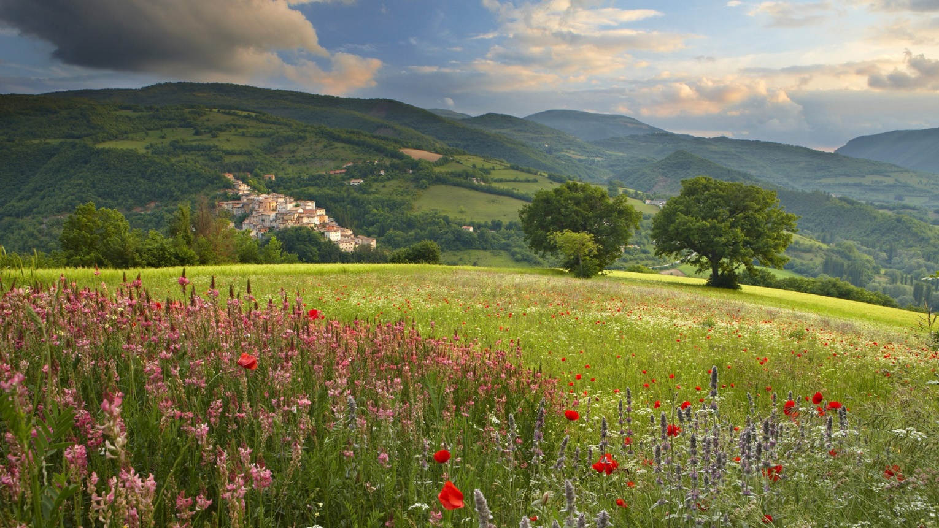

GOOD NEWS SERVICE #56: Spring/18

Editorial: Difficult as it would be to bring about, an independent foreign policy for Canada could be based on at least two major changes in existing policy. The first would be our withdrawal from supporting NATO’s nuclear weapon policies together with a simultaneous major increase in support of the UN, its specialized agencies and its 17 sustainable development goals. In the following articles are recorded the unsurpassed record by Canadians of the many functions of building and developing the United Nations. No other mid-sized country comes close to having done as much. The pity is that we are speaking of the past. What we need to ask of Canada’s policies now and in the immediate future: are they, as the famous song describes, just blowin in the wind?
1.”Peace cannot be secured by military force alone”: Pearson
“No person, no nation, no group of nations can view with comfort, however, the prospects for a world where peace rests primarily on the deterrent effect of collective military strength and regional political unity. That discomfort becomes deep anxiety in the face of the fantastic development of nuclear weapons and their inclusion in the armament of a few big powers now, and of many other powers soon. This makes it more than ever necessary, while maintaining military strength, to put forth every possible effort to reduce the danger of war and gradually make such strength unnecessary.
“In all the long story of mankind, arms alone, however powerful, have never been sufficient to guarantee security for any length of time. Your strength for defense becomes the weakness of those against whom you feel you must be ready to defend yourself. Your security becomes their insecurity; so they in turn seek safety in increased arms. A vicious circle commences which in the past has cost untold misery and destruction and might now, if we cannot cut through it, cause mankind's extinction. Even adequate collective force for defence, then, is no final solution. It is merely a means to an end:- peace based on something more enduring than force.”

2. Lester Pearson, Tommy Burns and their peace-keeping initiative which defused the Suez conflict
Canada's role as a peacekeeper throughout the world began in the 50's when Lester Pearson, Canada's ambassador to the UN suggested that the organization might create a peace keeping force. This force could be injected into a war or conflict area in order to maintain a ceasefire while the respective combatants negotiated an alternative solution to fighting. Canada is known throughout the world for its readiness to contribute troops or support to peace- keeping missions and has participated in more missions than any other country in the world.
The role of the United Nations supplying forces to keep the peace was first suggested by Lester (Mike) Pearson when he was serving at the UN as Canada's representative. This idea was not only adapted but has become one of the central fixtures in UN activities throughout the world. Pearson was awarded a Nobel Peace Prize for the inspiration and Canada became the most important and respected player in peacekeeping duties for the UN throughout the world.
However it was another Canadian, General “Tommy” Burns, who played a central role in bringing it about. When the British and French forces invaded Egypt to prevent the nationalization of the Suez Canal the danger of war increased. The battle-tested General Burns was able to restrain the hostility and to accept a peace-keeping military force acceptable to both sides.
3. Nine Canadians who heeded the Charter and built the UN: Keenleyside, Epstein, Humphrey, Reid, Elizabeth Mann Borgese, Chisholm, Sinclair. Arbour and King Gordon
Although the United Nations was founded by people from many different countries it is remarkable that so many of the earliest founders of the major programs were Canadian. Here are snapshots of nine of them:
- Hugh Keenleyside CC, was the first Director General of the United Nations Technical Assistance Administration. He was strongly opposed to nuclear power and all policies involving the use of nuclear weapons,

- William Epstein, OC, was the director of UN Disarmament Affairs and the sparkplug in founding the Latin American Nuclear Weapon Free Zone.

- John Humphrey, OC, wrote the first draft of the Universal Declaration of Human Rights. He also promoted December 10 as Human Rights Day.

- Escott Reid, OC, helped to write the founding document for the International Civil Aviation Organization (ICAO). He also produced the first draft of the UN Charter and the rules for the newly created United Nations.
- Elizabeth Mann Borgese, OC was an international expert on the oceans. She initiated and organized the first conference on the Law of the Sea. Her authority was recognized in subsequent efforts in upholding the laws for protecting our oceans.

- Brock Chisholm, CC was a psychiatrist and the first Director-General of the UN’s World Health Organization. He was also Head of the World Federation of Mental Health and considered to be one of the most influential Canadians of the Twentieth Century.

7) Adelaide Sinclair, OC was the Deputy Executive Director of UNICEF Programs and recognized as one of the highest ranking women at the UN.

8)Louise Arbour, CC, was recently appointed to be the UN Special Representative for International Migration, to develop a global compact on safe, orderly and regular migration. She was previously the UN High Commissioner for Human Rights, and Chief Prosecutor of the International Criminal Tribunal for Yugoslavia.

9) King Gordon, CM, in 1954, served as Director of Information for the United Nations Korean Reconstruction Agency in Seoul, then directed the UN Information Centre for the Middle East, based in Cairo. After the Suez Crisis, he moved to Gaza and became Information Officer for the United Nations Emergency Force under General Burns. Finally he was called to the Congo, in 1960, to work with the UN Emergency Force there as an information officer.

4. Seven more peacekeepers, reconcilers, ambassadors and/or
presidents of the UN Security Council

1) George Ignatieff, CC, described as “the best Prime Minister Canada never had”. was a key figure in Canadian diplomacy, including being an Ambassador to the UN and President of the UN Security Council in 1968-69.
2) Yves Fortier, CC was, from 1988 to 1992 Canada’s ambassador and permanent representative for Canada to the United Nations. In 1989 he served as president of the United Nations Security Council.
3) Douglas Roche, OC, for many years a Member of Parliament, then a Senator, founded the Middle Power Initiative. In 1984 he was appointed Canada’s Ambassador to the UN and was chosen to be Chairman of the UN’s Disarmament Committee.
4) Peggy Mason followed Senator Roche to become Canada’s ambassador for Disarmament. She is now the President of the Rideau Institute, an international affairs research institute think tank.
5) Romeo Dallaire, OC, is a Canadian humanitarian, author and General who commanded the ill-fated UN peacekeeping force for Rwanda in 1993-94. Unable to prevent the genocide, he was credited with personally saving thousands of lives while most of the world stood by. He then helped create the Child Soldiers Initiative before returning home to become a Canadian Senator.
6) Donald Ethell “In the searing heat of the Golan Heights in June 1984, little stood between two tense armies barely holding their ceasefires but a lanky unarmed Calgarian soldier named Donald Ethell...Over the course of 36 hours, he orchestrated tense negotiations and oversaw the exchange of more than 300 prisoners...” From Profiles in Humanitarian Courage, by Patricia Pearson.
7) Lois Wilson, CC, former President of the World Council of Churches often went where others feared to tread: to Chile under the repressive military dictatorship of Pinochet; to apartheid South Africa and to Argentina during the Dirty War, to meet with the Mothers of the Plaza.

5. CANADEM: Another conduit for Canadian contributions
This list of notable Canadians could be joined by the names of thousands of others who have made important contributions to peace, security and development. CUSO, CESO and scores of other NGOs have been enabling Canadians to get involved over many decades.
Among them is CANADEM, “an international … NGO dedicated to advancing international peace and security through the rostering, rapid mobilization and mission management of experts committed to international service with the UN, other IGOs, NGOs and governments.”
Since 1996 CANADEM has sent more than 5,000 people to missions in 77 countries. More than 40,000 civilian experts are now enrolled from Canada and increasingly from the global ‘south’ and other parts of the world and are available to the UN when needed. 65 different languages are now represented within the roster. Sponsored by the Canadian government, The British government, other nations and directly by international agencies, teams are working at this moment with Rohingya refugees in Bangladesh, as cease-fire monitors in Ukraine and are meeting other needs in Syria, Ethiopia, South Sudan, Congo, Nigeria, Yemen and beyond.

6. The importance of Canada’s mission to Mali
Globe&Mail, March 21/18 from an article by Robert Fowler: “... Over the past 35 years Canada despatched more than 125,000 soldiers and air force personnel to more than 30 mandated – and largely successful – peacekeeping operations in an effort to help manage an increasingly multi-faceted and intractable world, which was growing increasingly impervious to those efforts, But those efforts saved countless lives...Canadians depend a great deal on the health and efficacy of a universally accepted, rules-based international system for our own peace, prosperity and security.. And we should be bending every effort to help better order the world around us, striving to resolve complex and seemingly intractable disputes and conflicts and helping to protect their victims...”
7. Reader Help Requested: Norwegian Foreign Policy
This issue began with an editorial about Canadian foreign policy. Norwegian foreign policy is summarized in Wikipedia (sorry – we were getting desperate in our research) this way:
“Since the end of the Cold War, Norway has developed a model of foreign policy known as the "Norwegian model," the goal of which is to contribute to peace and stability through coordinated response among governmental and non-governmental Norwegian organizations; acting as an honest broker in international conflicts; an informal network of Norwegian individuals with access and credibility among parties; and the willingness to take the long view in international issues.”
The question is, what was the role of Norwegian citizens in helping to form this policy? There is a story that the Norwegian government facilitated round-table discussions throughout the country on the topic of “Norway’s place in the world”, and that these discussions led to a stance akin to Canada’s Charter of Rights and Freedoms in the sense that it is an articulated and abiding orientation in which all elected Norwegian governments of all stripes must anchor their evolving policies.
Can any of our readers shed more light on this story?
-----------------------------------------------------------------------------------------------------------
The Good News Service is produced & written by Murray Thomson, OC., Ottawa (623.224.8155) in collaboration with Randy Weekes of Lanark ON ( randylweekes@gmail.com ). We always like hearing from you, especially when you have liked hearing from us!
-------------------------------------------------------------------------------------------------------------

