A project of the Canadian Pugwash Group

Annual Report to Canadian Pugwash, October 2023

Submitted on behalf of the CNWC Steering Committee for the period September 2022 through August 2023.

EVENTS

1. CNWC/CIPS Lecture by Paul Meyer
“Nuclear Threats and Canadian Diplomacy” (November 2022)

In an event co-sponsored by CNWC and the Centre for International Policy Studies (CIPS), Paul Meyer delivered a major lecture on the state of international nuclear disarmament efforts, on the role of Canada, and on a number of policy initiatives that Global Affairs Canada should be pursuing. The full lecture is available in Appendix 1.

CNWC appreciates very much the opportunity to collaborate with CIPS – thanks to former director Prof. Rita Abrahamsen and current director Prof. Alexandra Gheciu.

2. Session with Parliamentarians – Breakfast meeting
Speaker: Paul Meyer

An all-party Parliamentary breakfast meeting, with the organizing support of Members of the House of Commons Heather McPherson and Elizabeth May, and Senator Marilou McPhedran. There was good support from all the parties. CNWC has over the years initiated many breakfast meetings with Parliamentarians – offering excellent opportunities for engagement with law-makers, and a reminder that providing Parliamentarians with information and analysis on nuclear issues is critically important.

We look forward to continuing these efforts in cooperation with a strengthened Ottawa chapter of the international Parliamentarians for Nuclear Non-Proliferation and Disarmament (PNND).

MEETINGS WITH GOVERNMENT

Engagement with Government of Canada policy-makers is an ongoing objective of CNWC, and in the past year two CNWC delegations held in-person meetings with officials.

3. Meetings with GAC (November 2022)
Delegation led by Paul Meyer
This delegation, which also included Douglas Roche, Jennifer Simons, Cesar Jaramillo, and Ernie Regehr, met with Global Affairs Canada officials from the Non-Proliferation and Disarmament and Defence Relations Divisions, and the Department of National Defence Security Policy Division.

4. CNWC Delegation to Ottawa (May 2023)
A second delegation of Doulas Roche and Cesar Jaramillo also met with several senior officials. A full report is available in Appendix 2.

CORRESPONDENCE WITH GOVERNMENT

A significant element of CNWC engagement with Government is carried out through correspondence with Government leaders. In all our correspondence with Government, we include copies to the leaders of all Parties in the House of Commons, and circulate letters more broadly to key Members of Parliament, Senators, Officials, and civil society.

5. Open Letter to Prime Minister
This letter Appendix 3 was also published as a full-page statement in The Hill Times, Appendix 4, and was signed by 64 Order of Canada endorsers of CNWC.

A substantive response was received from the Prime Minister (see Appendix 5).

CNWC then responded to the Prime Minister’s letter (Appendix 6).

6. Letter to Minister Joly
This letter to the Minister of Foreign Affairs, based substantially on Paul Meyer’s lecture referred to above, is available in Appendix 7. The Minister’s response is available in Appendix 8.

CNWC AWARD

7. 2022 CNWC Award
CNWC was proud to award Paul Meyer the 2022 CNWC Achievement Award for his extraordinary contributions to the pursuit of nuclear disarmament. Paul, who is of course well-known to the Pugwash community, was the 11th recipient of the annual award. Further details regarding his disarmament work are available in the CNWC media statement in Appendix 9.

On the occasion of the award presentation and Paul’s lecture, he was featured in a Hill Times report, available in Appendix 10.

A dinner in Paul’s honour – hosted by CNWC and as guests of The Simons Foundation – was held following the presentation and lecture.

GOVERNANCE/MISSION

8. CNWC Steering Committee
We were very pleased to announce that Alex Neve, O.C., former Secretary-General of Amnesty International Canada, has been named Chair of CNWC. Ernie Regehr is stepping down as CNWC Chair after five years in that role. The full announcement is in Appendix 11 and includes details on the appointment of two other prominent Canadians, Paul Meyer and Firdaus Kharas, to the Steering Committee.

Current Steering Committee Members:
Adele Buckley
Beverley Tollefson Delong
Cesar Jaramillo
Firdaus Kharas
Paul Meyer
Alex Neve, O.C.,
Ernie Regehr, O.C.
Douglas Roche, O.C.
Jennifer Allen Simons, C.M.

9. Recruiting Order of Canada recipient endorsers
A unique feature of CNWC is the endorsement of more than 1,000 prominent Canadians who are recipients of the Order of Canada. Canadians continue to be appointed to the Order, and CNWC continues to invite recipients to endorse the CNWC mission and the goal of a world without nuclear weapons.

10. CNWC Website
There was significant work on the CNWC website over the past year. We are especially indebted to Robin Collins for his work in getting the CNWC website integrated with that of the Canadian Pugwash Group. Others involved include Beverley Delong, Adele Buckley, and Cesar Jaramillo. We invite you to have a look at:
https://nuclearweaponsconvention.ca/?option=com_content&view=category&layout=blog&id=1&Itemid=3

11. Mission and purpose
The CNWC mission is to support and promote nuclear disarmament in all its dimension, with ongoing attention to the need for a comprehensive agreement or convention through which to codify all the agreements, regulations, institutional arrangements, and verification measures essential for accomplishing the prohibition and irreversible elimination of nuclear weapons.

See website at this link:
https://nuclearweaponsconvention.ca/2012/12/02/mission/

THANK YOU

12. Thank you
As we have emphasized in previous annual reports to CPG, CNWC is a volunteer-led project and thus relies on a wide range of individual effort and organizational support. Not all can be listed here, but with special thanks we draw your attention to the following:

• The Canadian Pugwash Group is the sponsoring organization for the CNWC project and, in addition to the important public affirmation that comes with that sponsorship, the CPG also brings critically important financial and administrative support, the latter coming especially via the CPG Treasurer who looks after the financial administration. Special thanks to CPG Chair Cesar Jaramillo and Treasurer Peter Venton.

• The Simons Foundation Canada has provided CNWC key grants to support the administration of the project, and in the Fall of 2020 the Foundation assumed basic secretariat services for CNWC. Special thanks to Dr. Jennifer Allen Simons, the Foundation president, and Elaine Hynes, who carries out the work of the CNWC secretariat.

• As always, we emphasize the critically important affirmation of the more than 1,000 recipients of the Order of Canada who have endorsed the CNWC call. They lend our work heightened credibility and are a manifestation of the broad support within Canada for effective action on disarmament. Many of the CNWC endorsers agree from time-to-time to sign on to our letters to the Government of Canada and other public statements.

• We are especially indebted to the distinguished jurilinguist Gérard Snow, a Member of the Order of Canada and CNWC endorser, for his ongoing translation services.

• The CNWC Steering Committee, made up of very busy people with myriad involvements, keeps the project running.

Submitted on Behalf of the CNWC Steering Committee
October 2023
Ernie Regehr, Co-Chair, CNWC Steering Committee
APPENDIX 1
CNWC/CIPS Lecture by Paul Meyer

“Nuclear Threats and Canada’s Disarmament Diplomacy”

Paul Meyer, CIPS/CNWC event, University of Ottawa, November 28, 2022

In reflecting on the troubling times we are experiencing, I am reminded of an anecdote about two men having a conversation - one a pessimist and the other an optimist. The pessimist is lamenting the impact of global warming, persistent pandemics, famine and pervasive conflict and he finally says “things are so bad they can’t get worse”. And the optimist responds “Sure they can!”.

Nuclear weapons and the existential threat they pose to humanity have assumed a new and disturbing saliency in the last few months. Russia’s aggression against Ukraine, accompanied as it is by persistent nuclear “sabre-rattling” and the blatant use of these weapons as instruments of intimidation and coercion has rudely reminded global society that huge arsenals of these weapons of mass destruction remain. But it could be worse. Humankind could be faced with the actual detonation of a nuclear weapon, demolishing a 77 year long taboo against their use.
As four generations have come and gone since the atomic bombing of Hiroshima and Nagasaki and the mass slaughter they caused, the horrific reality of a nuclear weapon detonation has faded from public consciousness. It helps explain the all too casual manner in which some are speculating about scenarios for the use of a tactical nuclear weapon in Ukraine, as if this was just another explosive weapon. Many in society seem to have assumed that with the end of the Cold War nuclear weapons disappeared, whereas some 12,000 of these warheads are extant, thousands of which are being maintained on a high-alert status allowing their launch in a matter of minutes. This year the keepers of the so-called “Doomsday Clock” at the Bulletin of the Atomic Scientists have set it at 100 seconds before midnight on the basis of nuclear and climate risks– and that determination was done in January before the Russian invasion of Ukraine. I will let you guess where the hands of the clock will be set in the new year.

In this lecture I would like to describe the current state of nuclear weapons as a factor in international relations, explain how we got to this point, review efforts made to agree on arms control and disarmament measures and conclude with some thoughts on what diplomatic role Canada could play in reducing nuclear dangers.

The very first resolution ever adopted by the UN General Assembly in January 1946 was devoted to the establishment of an Atomic Energy Commission that was to seek the elimination of atomic weapons from the world’s arsenals while channeling atomic energy for peaceful purposes. High-minded as this effort was, it soon fell victim to the growing divide between the West and the Soviet Union. The scheme championed by the US, named after its chief delegate to the new Commission, was the Baruch Plan, which envisaged all UN member states signing a treaty providing for international control of the atomic bomb after which the US would agree to eliminate its arsenal. The USSR countered that the US should destroy its bombs first and then one could develop a treaty regime. A further sticking point was the US insistence that no permanent member of the Security Council could use its veto on an atomic issue, a constraint that Moscow was not prepared to accept in a Council in which the US and allies held a majority.
Thus, the small window of opportunity to eliminate nuclear weapons when they numbered no more than the fingers on one hand was missed, never to reappear. The Soviet Union soon broke the US monopoly of the bomb and a frenzied arms race ensued with the two camps amassing tens of thousands of these weapons, representing an overkill of immense proportions.

Last month we marked the 60th anniversary of the Cuban Missile Crisis, the closest we have come to peering into the abyss of nuclear war. The more that crisis is studied the clearer have become the risks, some unknown at the time, that nuclear weapons would have been used. The respective leaders were simply unable to control every aspect of developments and the fact that nuclear war was averted may have relied as much on luck as it did on diplomacy. Clearly the “near death experience” of the Cuban missile crisis left its mark on both Khrushchev and Kennedy. It provided the impetus for the first post-war arms control measure, the 1963 Partial Test Ban Treaty that prohibited all but underground testing of nuclear weapons.

A few years later the most important nuclear-related agreement was concluded. The (Nuclear) Non-proliferation Treaty (NPT) which entered into force in 1970 and currently has 191 states parties is often referred to as “the cornerstone” of the global nuclear edifice. It enshrines a “tripartite bargain”. First, all but the five nuclear weapon states at the time the treaty was negotiated (NWS -the US, USSR, UK, France and China) foreswear acquiring nuclear weapons. Second, under Article VI of the treaty, the five NWS commit to negotiations to end the arms race at an early date and effect nuclear disarmament and third, all parties will cooperate on the use of nuclear energy for peaceful purposes. This framework has largely governed global nuclear affairs ever since, but its discriminatory nature in creating two categories of nuclear weapon “haves” and “have-nots” has generated ongoing problems. Three nuclear-armed states: India, Pakistan and Israel never joined the treaty and another, North Korea joined but then withdrew in 2003 to openly pursue a nuclear weapons program.

The non-proliferation obligations under the NPT were strictly enforced with a dedicated organization, the International Atomic Energy Agency delegated to monitor implementation through a series of bilateral safeguard agreements. However, there was no corresponding organization to monitor compliance with the disarmament obligations and this aspect was essentially left to the NWS themselves to determine. Not surprisingly, these states claimed they were fulfilling their disarmament obligations at the NPT’s Review Conferences held every five years. The NPT had an original term of 25 years which meant that in 1995 the Review Conference had to make a decision on the treaty’s extension. In the event a decision was made to extend the treaty indefinitely. This formed part of a package of decisions that also included outlining a set of disarmament objectives, plus specifying a strengthened review process and a resolution promoting a NWFZ for the Middle East. Suffice it to say that implementation of these commitments has proved inadequate and many NPT members are suffering “buyer’s remorse” for having agreed to give up the leverage that fixed extension terms might have provided them.
Although the NPT envisaged the five NWS negotiating nuclear disarmament, the reality is that not a single nuclear weapon has been eliminated pursuant to the NPT and multilateral negotiations. The only reduction of nuclear forces has occurred via bilateral talks between the US and the Soviet Union/Russia. Three of the five NWS have not participated in any collective reduction process, nor have the four non-NPT states possessing nuclear weapons. The positive momentum for arms control in the late 1980s and early 1990s – that produced the Intermediate Nuclear Forces Treaty, the Chemical Weapons Convention and the Comprehensive Test Ban Treaty has effectively petered out and gone into reverse. Twenty-six years after its conclusion in 1996, the CTBT has not entered into force as eight states required for this to happen (including the US and China) have refused to take the necessary steps. The Soviet-US 1972 Anti-Ballistic Missile Treaty for thirty years had underpinned strategic stability between the nuclear superpowers. It did this by sharply restricting ballistic missile defences and hence acting as a disincentive for these states to increase their arsenal of offensive missiles to overcome the defences. In 2002 the George W. Bush Administration abrogated the ABM Treaty in order to pursue national missile defences, thus prompting Russia and China to increase their own offensive strategic forces in order to sustain their capacity to retaliate if attacked. This factor has bedevilled negotiations between Russia and the US ever since. It has been exacerbated in recent years by the termination of the INF Treaty with accusations of Russian cheating and the suspension of the bilateral strategic dialogue in the wake of Russia’s invasion of Ukraine. The sole remaining bilateral nuclear restraint treaty – the New START accord, is set to expire in February 2026 and no talks are currently active to develop a successor agreement despite both sides saying that this is their intention.

The current geo-political tensions and the return of military aggression against a sovereign state in Europe, has led the US and its nuclear dependent allies to stress nuclear deterrence rather than nuclear disarmament as the path forward. China and India, alone of the nuclear armed states have declared a “No First Use” doctrine – i.e. that they would only resort to using nuclear weapons if they were attacked by nuclear weapons. The others have opted for “strategic ambiguity” suggesting that nuclear weapons could be employed first and against a variety of non-nuclear strategic attacks. These could cover almost anything from cyber attacks to destructive acts against critical infrastructure. If some of the most powerful states in the world still cling to nuclear weapons for a broad range of scenarios, is it any wonder that other states may wish to acquire these same weapons and avail themselves of the supposed security “benefits” ascribed to nuclear weapons by those possessing them? We could be facing a new era of nuclear proliferation.

The doctrine of nuclear deterrence essentially rests on the capacity to deter hostile actions on the part of an adversary by threatening retaliation via the aptly named acronym- MAD for Mutually Assured Destruction. The effectiveness of nuclear deterrence cannot be empirically determined nor is it possible to demonstrate all the risks inherent in the existence of nuclear forces. There is however ample evidence of close calls and nuclear weapon-related accidents as a result of human and/or technical errors. Some have suggested that the reason we have not experienced a nuclear weapon detonation to date has to do more with “sheer, dumb luck” than with human ingenuity.
The irresponsible nuclear rhetoric recently voiced by President Putin is “playing with fire” and underlines the danger of nuclear armed autocracies where no checks on the dictator exist. Putin’s cynical rhetoric should not blind us to the nuclear threats issued by other leaders in recent years. Remember the “Fire and Fury like the world has never seen” that former President Donald Trump directed against North Korea, followed by his boast that his nuclear button was bigger than that of the North Korean leader. And just reflect on the following leaders of nuclear armed states, several of whom are still in power: Vladimir Putin, Xi Jinping, Narendra Modi, Boris Johnson, Bibi Netanyahu, Imran Kahn and Kim Jung Un - hardly paragons of sobriety and prudence. What would be their reactions in a crisis situation? What certainty can we have that under pressure, whether real or perceived, a leader might not have recourse to the nuclear weapons they possess? There is greater certainty that once a nuclear weapon has been used, subsequent escalation will elude efforts to control it. As President Biden has warned, the situation once the nuclear weapon threshold has been crossed, could quickly rise to “Armageddon” levels.

Dissatisfaction with the NPT-centred regime for global nuclear non-proliferation and disarmament has been growing for some time on the part of the non-nuclear weapon states (NNWS). Not only had the five NWS made scant progress on their nuclear disarmament obligations, they are all engaged in multi-year, multi-billion dollar modernization programmes indicating their intention to retain their nuclear forces for decades to come. When pressed on their disarmament commitments, the NWS and those sheltering under the nuclear umbrella, respond that the international security environment precludes making progress on arms control as if there is ever a right time to negotiate. Let us recall that most of the major arms control agreements were concluded during the intense ideological and armed confrontation of the Cold War. Will rather than timing is the crucial factor.

In the agreed outcome document of the 2010 NPT Review Conference (the last such conference to produce an outcome as the 2015 and 2022 review conferences failed to do so), a single sentence heralded a new approach to the problem posed by nuclear weapons. The sentence expressed the conference’s deep concern over the catastrophic humanitarian consequences of any use of nuclear weapon and the need to prevent such a devastating act. This acknowledgement gave rise to what became known as the “Humanitarian Initiative” which framed the risks posed by nuclear weapons as a humanitarian and environmental issue and not simply a security one. The International Committee of the Red Cross was an early champion, stressing that no adequate humanitarian response was possible in the wake of a nuclear weapon detonation with its horrific combination of blast, heat and radioactivity and the prohibition of these weapons was the only sure way to ensure they were not used.

The “Humanitarian Initiative” also highlighted the grave environmental damage of even a limited nuclear war. Scientists projected that a nuclear war in South Asia employing a hundred nuclear weapons would send so much soot into the stratosphere as to lower the global temperature for years and yield a 20% reduction in food production. “Humanitarian Initiative” supporters pressed for action via the UN General Assembly calling for filling the existing “legal gap” by means of a treaty prohibiting nuclear weapons. This initiative was successful and led a couple of years later to the negotiation of such a prohibition treaty. As the NWS and their allies chose to boycott these negotiations (a rather shameful action for a duly authorized UN process), the development and agreement on a text proceeded relatively rapidly. On July 7, 2017 the Treaty on the Prohibition of Nuclear Weapons (TPNW) was adopted by a vote of 122 in support to one objection and one abstention. Upon achieving its 50th ratification, the TPNW officially entered into force in January 2021. It currently has 68 states parties and 91 signatories.

The TPNW sets a new, higher standard for nuclear disarmament than does the NPT. The TPNW prohibits the possession of nuclear weapons, their use and even the threat of their use. In this way, it fills the “legal gap” by treating nuclear weapons in the same manner under international law as the other weapons of mass destruction (chemical and biological weapons), namely through comprehensive prohibition treaties, the Chemical Weapons Convention and the Biological Weapons Convention. The TPNW also explicitly stigmatizes nuclear weapons as immoral and illegal arms whose use would be contrary to international humanitarian law and repugnant to the public conscience. Importantly, the treaty in addition to its prohibitions also has positive obligations, namely, to assist victims affected by nuclear weapon use or testing and help in environmental remediation of areas contaminated by such testing.

Although both supporters and opponents of the TPNW are parties to the NPT, the advent of this new treaty has opened up a schism between the camps with respect to fulfilling the NPT’s Article VI obligation on nuclear disarmament. The NWS and allies adhere to what they describe as “the step by step” approach towards disarmament whereas the TPNW supporters say that if any steps are being taken at all they are going backwards not forward. According to them, the TPNW sets out a “fast track” path to nuclear weapon abolition if only the nuclear armed states were prepared to follow it.

So, where does Canada stand in this debate and what role could it play in advancing shared nuclear disarmament objectives? All 191 NPT states parties have an obligation to promote the disarmament aims of the treaty. Even NATO while proclaiming that it will be a nuclear alliance as long as nuclear weapons exist, also has a stated goal of helping to bring about a world without nuclear weapons.

Let me now raise five issues which I believe could benefit from a new approach by Ottawa.

First, a more respectful attitude towards the TPNW is warranted. Canada has been a longstanding supporter of multilateral arms control and disarmament as well as a champion of international humanitarian law, which is generally acknowledged to be incompatible with nuclear weapon use. Before the TPNW process got underway, it was easy for Canada to proclaim its support for the NPT, including the efforts at past NPT Review Conferences to stipulate specific steps to be undertaken by the NWS to demonstrate progress in implementing the core, but vaguely worded, Article VI disarmament commitment. The TPNW with its more demanding requirements and its explicit stigmatization of nuclear weapons and the threat to use them, posed a dilemma for Ottawa. It would have to choose between its support for nuclear disarmament and its support for nuclear deterrence. As it happens, deterrence trumped disarmament and Canada has stood aloof from the TPNW since its inception. Beyond rejecting the treaty, Ottawa also engaged in suspect criticism of the accord, claiming that it somehow was incompatible with, and undermined the NPT rather than representing one potential route to fulfill that treaty’s Article VI disarmament obligation.

Canada suggested that adherence to the TPNW would be inconsistent with its NATO commitments. Actually, there is no legal requirement for NATO members to support the Alliance’s nuclear policy, which is simply a policy subject to change. In fact over the years several NATO members have dissented or reserved their position regarding nuclear weapon-related issues without imperilling their Alliance membership (which after all is based on common values and interests and not subservience to any particular weapon system). Regrettably, Ottawa also missed an opportunity to act as a bridge-builder by refusing to attend as an observer, the first meeting of states parties of the TPNW held in Vienna in June. Many voices in civil society urged the Government to participate but Ottawa refused, mumbling about NATO commitments even though fellow NATO members Germany, Norway, Belgium and the Netherlands were all present alongside US ally Australia. As a sovereign state, Canada has the choice whether or not to sign up to an international agreement, but it doesn’t burnish your good multilateralist credentials to snub those you have some disagreement with.

Second, Canada should be more active in shaping NATO policy on deterrence and disarmament. How NATO develops its nuclear policies will have much significance for the future security landscape. In June, 2018 the House Standing Committee on National Defence issued a unanimous report on NATO, including a series of recommendations. One of these focused specifically on nuclear threats and reads in part: That the Government of Canada take a leadership role within NATO in beginning the work necessary for achieving the NATO goal of creating the conditions for a world free of nuclear weapons. That this initiative be undertaken on an urgent basis in view of the increasing threat of nuclear conflict …

The Government in its reply stated that it agreed with this recommendation but gave no indication as to how it intended to carry out this initiative. Indeed, subsequently there was complete radio silence regarding what Canada was advocating within NATO Councils as part of the review of the Alliance’s chief policy document the “Strategic Concept” and no evidence that it had acted upon the Parliamentary direction. This “Strategic Concept” was duly adopted at the June 2022 Madrid Summit and largely reiterated the status quo when it came to nuclear matters. An alternative tack would have Canada encouraging the Alliance to adopt a “No First Use” doctrine as a way of reducing nuclear risks and the role of nuclear weapons in security policies by strictly limiting the circumstances when their use could be contemplated.

Third, Canada could take more of a leadership role in cooperating with other like-minded states to promote disarmament goals. Canadian capacity for leadership on disarmament files has been in decline for some time. The era when Canada was instrumental in concluding the Ottawa Convention banning anti-personnel landmines is now a distant memory. That activism was supported by the Department of Foreign Affairs Verification Research Unit which generated innovative solutions to a variety of verification problems and a program that drew upon Canadian non-governmental expertise via commissioned research, assets that were terminated years ago.

Currently, we are more likely to be followers on international security initiatives that others are leading. An example is the 16 nation Stockholm Initiative on Nuclear Disarmament, a Swedish initiative to mobilize NNWS to strengthen the NPT in the run-up to its 10th Review Conference. The Stockholm Initiative has held six ministerial level meetings since its inception in 2019. At none of these was Canada represented at the ministerial level. I believe it was Woody Allen who said that “90% of success in life is just showing up” and we should heed this advice. Even more appropriate would be for Canada to offer to host a Stockholm Initiative meeting and provide a further impetus to its work.

Fourth, it is time for Canada to take a new tack on a long-standing disarmament goal. This is the Fissile Material Cut-off Treaty (FMCT) a long-standing agreed objective of NPT states, which envisages a ban on the production of fissile material, the essential ingredient for nuclear weapons. Canada has taken traditionally a lead role in promoting this envisioned treaty on which it has expended considerable time and energy. All of the five NWS have said they support this treaty although there remain major questions regarding its scope, chiefly whether existing stockpiles as well as future production would be restricted. Canada has led on several expert studies of key issues relating to the fissile material treaty, issues which in my view will need the pressure of actual negotiations to be resolved. But for all the lip service paid to “immediate” commencement of such a negotiation, it has never seen the light of day. This is a direct result of Canada, along with several other states, insisting that negotiations can only occur in the 65-nation Conference on Disarmament in Geneva, a body that operates under such an extreme version of the consensus rule that it has not been able to agree on and implement a Program of Work for over 25 years. To continue to confine any negotiation to this moribund forum is to effectively bury it.

Those who seriously wish to advance multilateral disarmament negotiations need to do so via authorization by the UN General Assembly which makes its decisions by majority vote and can’t have its work stymied by the de facto vetoes of a handful of states. For Canada to repeatedly tie the initiation of negotiations of a fissile material treaty to the Conference on Disarmament recalls Einstein’s definition of insanity: to do something over and over again and expect different results. Persisting in this diplomatic folly is no credit to past efforts and undermines the credibility of multilateral disarmament forums. It is telling that when the UK wanted to get something done on two issues officially on the agenda of the Conference on Disarmament, namely conventional arms transfers and outer space security, they immediately opted for the General Assembly route which yielded the 2013 Arms Trade Treaty and the current UN Open Ended Working Group on reducing space threats. Where there is a will there is a way.

Ideally, Canadian disarmament diplomacy would be operating as one component of an overarching foreign policy. This government however has not produced one. In fact there has been no review of foreign policy since 2005. A “Feminist Foreign Policy” has been promised by the current government, although one has yet to surface publicly. To be truly a feminist policy, it should reflect feminist values and approaches. It is fair to say that threatening under certain unspecified conditions to use a weapon of mass destruction that would incinerate men, women and children without distinction is antithetical to those values. We would hope that any articulation of the said feminist foreign policy would stress the imperative of seeking diplomatic solutions to international disputes and advocating for active measures to promote nuclear disarmament.

Finally, Global Affairs Canada should revive a regular consultation with civil society on disarmament issues. There was a period when the Department engaged with civil society and academic experts on a regular basis by means of annual, structured consultations across the spectrum of non-proliferation, arms control and disarmament issues. Global Affairs Canada has abandoned this form of regular, substantive consultation with civil society although I can attest that the practice yielded benefits for all concerned. It has been increasingly difficult to obtain explanations for the positions adopted by Canadian representatives in international forums and even routine statements are not made available. All Canadians have a stake in preventing nuclear war and in a democracy, it is incumbent on government to keep its citizens informed about the international security measures it is pursuing.

To conclude, I return to my opening anecdote about the pessimist and the optimist. It is important to be clear-eyed in assessing the threats, nuclear and otherwise that could endanger our security, and there are many confronting us today. At the same time, I want to stress that as a former diplomat I remain a professional optimist and believe firmly that with an application of pragmatism and resolve the nuclear demons can be kept at bay and ultimately eliminated. It is time for Canada to reinvest in its nuclear disarmament diplomacy and help bring us all closer to that world without nuclear weapons that humanity aspires to.

Thank you for your attention.
APPENDIX 2
CNWC Delegation to Ottawa (May 2023) Full Report

This is an edited version of the report Douglas Roche submitted to the CNWC Steering Committee following the CNWC’s delegation meetings with Government of Canada officials and key parliamentarians May 16-19, 2023.

To: CNWC Steering Committee
From: Douglas Roche and Cesar Jaramillo
May 19, 2003
A. GAC

Interpretive report of our meetings with Rob Oliphant, Parliamentary Secretary, Foreign Affairs, and Kevin Hamilton, Director-General, International Security, Global Affairs Canada (GAC), and a team of officials.
1. The CNWC Brief had been sent in earlier. At both meetings, we were told the Government was in accord with our principal point that nuclear weapons negotiations, particularly between Russia and the U.S., are even more vital now than before the Ukraine war and should not be put off until the Ukraine war is resolved. GAC agree with us that nuclear disarmament must continue despite the war and, separately, they (GAC) confirmed that a G7 statement on nuclear disarmament would be forthcoming. As an indication of Canada’s commitment to getting the Russia-U.S. strategic dialogue going again, we were told that Canada would not interfere with Russian planes flying through Canadian air space to get to inspection sites in the U.S.
2. On Canada implementing the House of Commons Defence Committee’s recommendation to push NATO toward nuclear disarmament work, the officials said they were doing this quietly, but their work seems to consist mostly of softening the hawkish drafts of NATO’s policy statements. There was no sign of any creative action to move NATO away from the “supreme guarantee” designation of nuclear weapons.
3.We were told that Canada is working to advance the idea of Fissile Materials Control/Cut-off Treaty (FMCT) negotiations being held in the UNGA rather than the Conference on Disarmament (C.D.) This does constitute a change in Canadian policy (which has hitherto insisted such negotiations must be held in the C.D., moribund as it is). It was suggested that, with the U.S. already on board, it remained only to convince the U.K. and France to switch to the UNGA idea for a resolution to this effect to be presented at the First Committee this fall. If such a resolution does appear, it would be a significant victory for Canada’s push over the years to obtain a FMCT. Canada will not insist that negotiations necessarily be about a “cut-off” (the C in FMCT) and that once negotiations begin all options would be on the table. We recommend that CNWC find a way to publicize and otherwise advance the UNGA possibility.
4. It was stated to us that Canada is not considering attending the second meeting of the States Parties to the Treaty on the Prohibition of Nuclear Weapons (TPNW). The attendance at the first meeting of four NATO countries (Germany, the Netherlands, Norway and Belgium) has — apparently —not swayed those who influence policy at GAC. But there is certainly not unanimity on this inside the Government. According to GAC, attendance by the four NATO states was not cost-free and they got blowback in internal NATO discussions. It was suggested that if Parliament adopted a motion calling on Canada to attend the Second Meeting of States Parties (2MSP), that would result in attendance. When we presented the letter P.M. Trudeau wrote to Ernie Regehr on April 17, 2003, stating that Canada “will remain engaged in all multilateral fora,” leading us to argue that this included the TPNW, we were advised that the P.M. made a “semantic” error. We proposed that the P.M.’s letter showed that GAC was out of step with the P.M., but the officials did not agree. Nonetheless, they did appear embarrassed to have to argue that the TPNW is not a legitimate multilateral forum for Canada to join.
B. Parliamentary Breakfast

1. Three parliamentarians attended breakfast meeting: Elizabeth May, Green; Lindsay Matheson, NDP; Senator Marilou McPhedran. Eight parliamentarians were invited.
2. An initiative was taken to inform Dr. Hedy Fry, in her capacity as nominal Chairperson of PNND/Canada, that the group this morning would like to have a meeting in early September to revivify PNND/Canada of parliamentarians interested in joining.
3. The present CNWC Brief will be distributed to all parliamentarians now.
4. Consideration is being given to formulation of a motion calling on Canada to attend as an observer 2MSP.
5. Concern was expressed at possible confusion of parliamentarians about new group of parliamentarians for nuclear disarmament formed by International Campaign to Abolish Nuclear Weapons (ICAN). This morning’s group would like to know relationship/impact of ICAN group on PNND.
6. The meeting would like info on what PNND plans at OSCE meeting in July.
C. Michael Chong, M.P.

We had a nearly one-hour conversation with Michael Chong, M.P., Conservative Foreign Affairs critic. He brought James Bezan, M.P, Conservative Defence critic, who stayed for about half that time and who appeared not very interested in what we had to say. He seemed mainly focused on what NATO wants to do. Even though both M.P.s were supportive of the recommendation concerning Canada pushing for saving New START, they did not think the timing was right for Canada to act on the House of Commons Standing Committee on Defence recommendation that Canada take a leadership role within NATO given the backdrop of the Ukraine conflict.
However, Mr. Chong proved to be thoughtful and reasonably well informed on principal nuclear disarmament issues. He took notes for what he suggested would be a forthcoming question in the House of Commons on prodding Canada to support/push for U.S. and Russia to resume talks for resuming START II and beginning work on the proposed successor treaty. He said Canada is not pulling its weight on either arms spending or ODA, and that if Canada is to be taken seriously in international fora, we have to spend more money in these fields. He thinks the 2% GDP military spending target should be achieved by Canada.

D. Senator Peter Boehm

Meeting for a half hour with the Chairman of the Senate Foreign Affairs Committee, who has just produced a formal Senate report, “Strengthening Canada’s Autonomous Sanctions Architecture,” of which he is quite proud. As a former sherpa for Canadian Prime Ministers, he anticipates that the forthcoming G7 Statement on Nuclear Disarmament (Hiroshima) will help to advance the CNWC Brief. He is strongly in favour of Canada attending 2MSP and may raise this in the Senate. He noted with interest the Canadian UNGA negotiation course of FMCT.

E. The Senate

The delegation was introduced in the Senate, a salute originated by Senator Marilou McPhedran.

F. The Hill Times

The delegation paid a courtesy call on Anne-Marie Creskey, publisher of The Hill Times, to express CNWC thanks for the free one-page ad given to us in February to promote the CNWC letter to the Prime Minister signed by 64 recipients of the Order of Canada.
APPENDIX 3
Open Letter to Prime Minister

February 21, 2023

Open Letter to Prime Minister Justin Trudeau

Confronting the Nuclear Threat

A year later, the attack on Ukraine has confirmed the
nuclear threat to be real, imminent, and existential.

Dear Prime Minister,

With the world challenged by climate disasters, pandemics, regional wars, growing numbers of refugees, food insecurity and more, Russia’s attack on Ukraine has driven the nuclear threat out of the political shadows, exposing yet another crisis that is real, imminent, and existential.

President Vladimir Putin’s direct and implied threats to use nuclear weapons have shocked and angered the world, with NATO Secretary-General Jens Stoltenberg calling the threats “dangerous and irresponsible.” President Joe Biden has warned that Armageddon would be the inevitable result once the nuclear threshold was crossed.

The five permanent members of the UN Security Council (US, Russia, UK, France, China) have declared that “a nuclear war cannot be won and must never be fought.” The G20 recently stated that “the use or threat of use of nuclear weapons is inadmissible.” Two measures designed to help prevent the “inadmissible” from happening are no-first-use commitments and the de-alerting of strategic nuclear weapons.

Therefore, Prime Minister, we call on the Government of Canada to:

1. Urge NATO and its three nuclear weapon state members (US, UK, and France) to commit never to be the first to launch a nuclear attack, and to work toward universalizing that commitment (which China and India have already made); and

2. Encourage the United States and Russia to take all their strategic nuclear weapons off high alert (of the nine states with nuclear weapons, only the US and Russia maintain dangerous high-alert deployments).

We also urge you to publicly acknowledge the current nuclear crisis and call on all states with nuclear arms to honour the norm against nuclear weapons use that has been respected for the 77-years since the bombings of Hiroshima and Nagasaki.

Adopting these measures alone would, of course, not end the nuclear crisis, but it would make the world safer. It would diminish the likelihood of escalation to nuclear use in a conventional war. It would radically reduce the risk of the inadvertent launch of strategic nuclear weapons in response to false warnings of attack. It would also encourage a geopolitical environment more conducive to further progress in nuclear disarmament.

There will never be an easy time to mitigate and eventually eliminate the nuclear weapons threat to our planet; it is vital to act now.
-----------------------------------------------------
21 février 2023
Lettre ouverte au premier ministre Justin Trudeau
Affronter la menace nucléaire

Une année plus tard, l'attaque contre l'Ukraine vient confirmer que
la menace nucléaire est bien réelle, imminente et existentielle.
Monsieur le Premier Ministre,
Dans ce monde déjà lourdement éprouvé par des désastres climatiques, des pandémies, des guerres régionales, un foisonnement de réfugiés et l’insécurité alimentaire, l’attaque russe en Ukraine a propulsé la menace nucléaire à l’avant-scène politique, provoquant encore une autre crise bien réelle, imminente et existentielle.
Les menaces tant expresses qu’implicites du président Vladimir Poutine de recourir aux armes nucléaires ont causé choc et colère partout dans le monde, le secrétaire général de l’OTAN, Jens Stoltenberg, qualifiant ces menaces de « dangereuses et irresponsables ». Le président Joe Biden a prévenu que l’Armageddon serait le résultat inévitable du franchissement du seuil nucléaire.
Les cinq membres permanents du Conseil de sécurité de l’ONU (É.U., Russie, R.U., France, Chine) ont rappelé qu’« une guerre nucléaire ne peut être gagnée et ne doit jamais être engagée ». Le G20 a déclaré récemment que « le recours aux armes nucléaires, ou la menace d’un tel recours, est inadmissible ». Parmi les mesures envisagées pour écarter la réalisation de l’« inadmissible », deux d’entre elles figurent depuis longtemps à l’agenda du désarmement : les engagements de non-recours en premier à l’arme nucléaire, et la diminution du niveau d’alerte des armes nucléaires stratégiques.
En conséquence, Monsieur le Premier Ministre, nous engageons le Gouvernement du Canada à prendre les mesures suivantes :
1. presser l’OTAN et ses trois États membres nucléarisés (É.U., R.U. et France) de s’engager à ne jamais être les premiers à lancer une attaque nucléaire, et de s’investir dans l’universalisation de cet engagement (que la Chine et l’Inde ont déjà donné);
2. encourager les États-Unis et la Russie à retirer toutes leurs armes nucléaires stratégiques du niveau d’alerte élevé (des neuf pays nucléarisés, seuls les États-Unis et la Russie maintiennent un niveau d’alerte élevé dangereux).
Nous vous pressons également de reconnaître publiquement la crise nucléaire actuelle et d’engager tous les pays nucléarisés à honorer la norme de non-recours aux armes nucléaires qui a été respectée tout au long de ces 77 dernières années depuis les bombardements de Hiroshima et de Nagasaki.
L’adoption de ces mesures ne suffira pas, bien évidemment, pour mettre fin à la crise nucléaire, mais elle augmenterait la sécurité mondiale. Elle diminuerait les probabilités d’une escalade nucléaire dans le cadre d’une guerre conventionnelle. Elle réduirait radicalement le risque d’un déclenchement accidentel d’armes nucléaires stratégiques en réaction à de fausses alertes. Elle favoriserait aussi un environnement géopolitique plus propice au progrès en matière de désarmement nucléaire.
Ce ne sera jamais tâche facile de diminuer, jusqu’à sa disparition complète, la menace nucléaire à l’échelle planétaire; il est essentiel d’agir maintenant.
Veuillez agréer, Monsieur le Premier Ministre, l’expression de nos sentiments les plus respectueux.
Sincerely,

Carolyn Acker C.M.
Founder, Pathways to Education Canada

Hon. Lloyd Axworthy, C.C.
Chair, World Refugee and Migration Council; former Minister of Foreign Affairs of Canada

Christopher R. Barnes, C.M.
Professor Emeritus, University of Victoria
Gerry Barr, C.M.
Former CEO, Directors Guild of Canada and Canadian Council for International Cooperation
Allan Gordon Bell, C.M.
Composer, Professor, University of Calgary
Robin Boadway, O.C.
Professor of Economics Emeritus, Queen's University
Paul Born, C.M.
Co-Founder and former CEO of Tamarack Institute; Senior Fellow, Ashoka
Mary Boyd, O.C.
Peter G. Buckland, C.M.
Co-founder and former President, Buckland and Taylor Ltd.
George D. B. Butterfield, O.C.
Co-Founder Butterfield & Robinson
Robert Carsen O.C.

Cathy Crowe, C.M.
Public Affiliate, Faculty of Arts, Toronto Metropolitan University

Shelagh Day, C.M.
Former Director of the Saskatchewan Human Rights Commission; President, Canadian Human Rights Reporter
Michael Dence, O.C.
Former Executive Director, The Royal Society of Canada

Howard Dyck, C.M.
Choral Conductor; Former CBC Radio Host of Choral Concert and Saturday Afternoon at the Opera
Michael N.A. Eskin, C.M.
Distinguished Professor, Faculty of Agricultural and Food Sciences, University of Manitoba

W. Paterson Ferns C.M.
President, Ferns Productions Inc.
Eric Friesen, C.M.
Former CBC Network Radio Host; Writer and Speaker on music, culture and faith
Robert Glossop, C.M.

Dr. Sherrill Grace, O.C.
Professor Emerita, The University of British Columbia
Judith G. Hall O.C.
Professor Emerita, The University of British Columbia

Hanny A. Hassan, C.M.
Past Chair, Council of Muslim Communities of Canada and Board of University of Western Ontario
R Brian Haynes, O.C.
Professor Emeritus, McMaster University
Paul Valdemar Horsdal C.M.
Valdy, Canadian Folksinger
Daniel Ish, O.C.
Professor Emeritus (Law), University of Saskatchewan
Bruce Kidd, O.C.
Professor Emeritus, University of Toronto
Bonnie Sherr Klein, O.C.
Documentary Filmmaker, Disability Activist
Kenneth Kramer, C.M.
Anita Kunz, O.C.
Dennis Lee, O.C.
Poet
Jacques Levesque, C.M.
Professor Emeritus, Department of Political Science, University of Quebec in Montreal
Margaret MacMillan, C.C.
Emeritus Professor, International History, University of Oxford; Emeritus Professor of History, University of Toronto
Teresa MacNeil, C.M.

Stephanie Mancini, C.M.
The Working Centre

Peter G. Martin, O.C.
Professor, Canadian Institute for Theoretical Astrophysics, University of Toronto
David Matas, O.C.
Lawyer, International Human Rights
Gordon A. McBean, C.M.
Nobel Laureate for contributions to Intergovernmental Panel on Climate Change (2007); Professor Emeritus, Western University
Roy Miki, C.M.
Robert V. Moody, O.C.
Emeritus Professor, University of Alberta
T. Jock Murray O.C.
Professor Emeritus, Dalhousie University
Alex Neve, O.C.
Senior Fellow, Graduate School of Public and International Affairs, University of Ottawa
Peter Newbery, C.M.
Clinical Prof. Emeritus in Family Medicine, University of British Columbia
Michael Ondaatje, O.C.
Novelist, Poet, Filmmaker

John C. Polanyi, C.C.
Nobel Laureate (Chemistry, 1986) University Professor Emeritus, University of Toronto
Lola Rasminsky, C.M.

Ernie Regehr O.C.
Co-Founder and former Executive Director, Project Ploughshares; Senior Fellow, The Simons Foundation Canada
Catherine Robbin, O.C.,
Associate Professor Emerita, York University

Hon. Douglas Roche, O.C.
Former Canadian Senator, Member of Parliament, and Ambassador for Disarmament

Ronald Rosenes, C.M.
Susan Sherwin, C.M.
Distinguished Research Professor, Emerita, Dalhousie University
Karl Siegler, C.M.

Jennifer Allen Simons C.M.
Founder and President, The Simons Foundation Canada; Founding Partner, Global Zero
John P. Smol, O.C.
Past President, Academy of Science, Royal Society of Canada
Gérard Snow, C.M.
Jurilinguiste, autrefois de l'Université de Moncton
Ian Tannock, C.M.
Emeritus Professor of Medicine, University of Toronto
Veronica Tennant, C.C.
Filmmaker, Author, Former Prima Ballerina National Ballet of Canada
Setsuko Thurlow, C.M.
Hiroshima Atomic Bomb Survivor and Nobel Peace Prize
Recipient on behalf of the International Campaign to Abolish Nuclear
Weapons, 2017
Jane Urquhart, O.C.
Novelist and Poet
Michel Vennat, O.C.
James Walker, C.M.
Distinguished Professor Emeritus, University of Waterloo
David Waltner-Toews, O.C.
University Professor Emeritus, University of Guelph
Dr. Gary Warner, C.M.
Professor Emeritus, McMaster University
Dr. Fred Wien, C.M.
Professor Emeritus, Dalhousie University
APPENDIX 4
Open Letter to Prime Minister, published by The Hill Times and signed by 64 CNWC endorsers
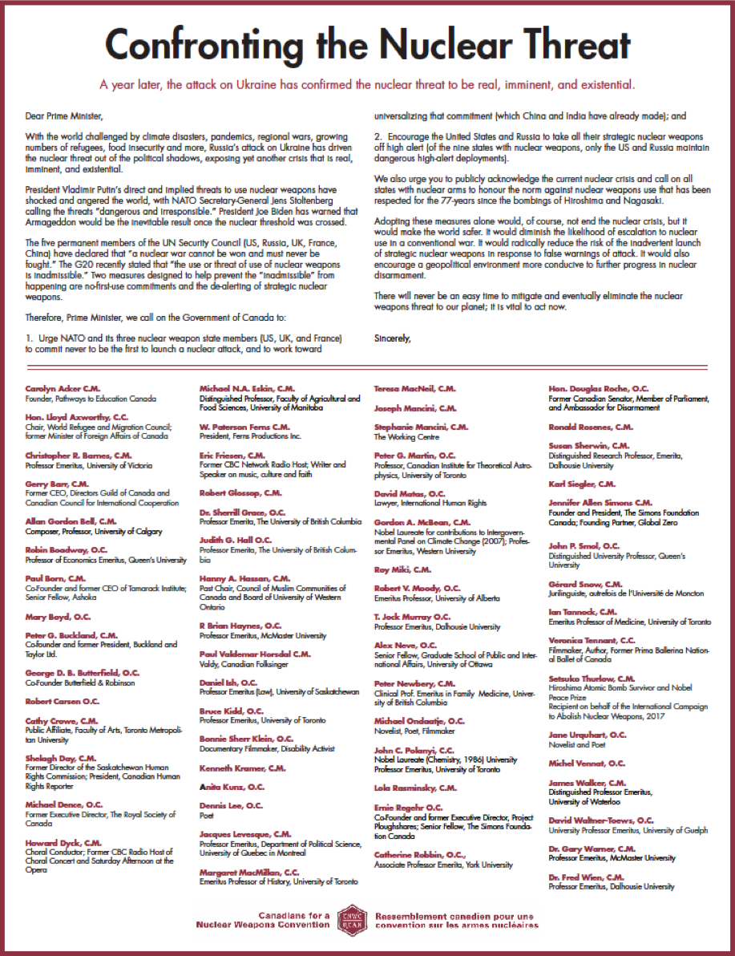

APPENDIX 5
Response received from Prime Minister

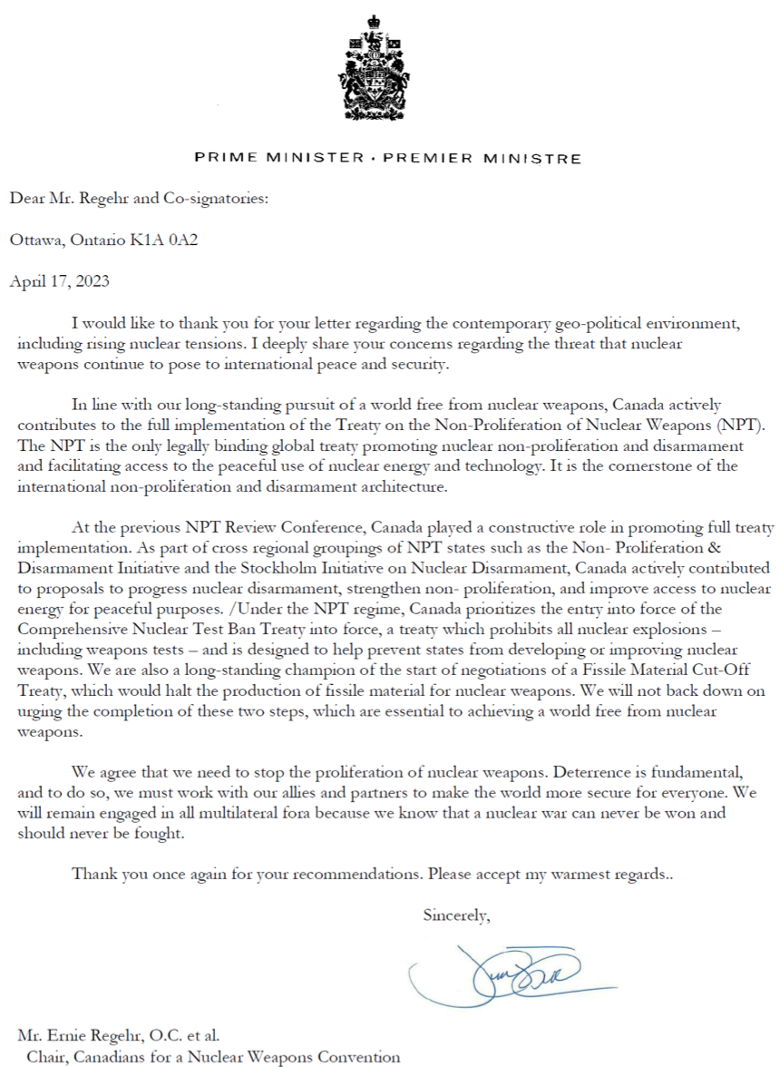
APPENDIX 6
CNWC’s response to Prime Minister

July 10, 2023

The Right Honourable Justin Trudeau, P.C., M.P.
Prime Minister of Canada
Office of the Prime Minister
80 Wellington Street
Ottawa, ON K1A 0A2

Dear Prime Minister,

On behalf of Canadians for a Nuclear Weapons Convention (CNWC), we wish to acknowledge receipt of your April 17 reply to our letter to you of February 21. We share the deep concern you expressed regarding the threat that nuclear weapons continue to pose to international peace and security. This threat is exacerbated by the war in Ukraine and makes it even more compelling for Canada to play a leadership role in furtherance of nuclear non-proliferation and disarmament. Your letter has prompted the following reaction on the part of CNWC:

While we are aligned regarding support for the Nuclear Non-proliferation Treaty (NPT) it is not accurate to assert that “The NPT is the only legally binding global treaty promoting nuclear non-proliferation and disarmament….” Since its entry into force in January 2021, there is another legally binding treaty dealing with this subject matter: the Treaty on the Prohibition of Nuclear Weapons (TPNW), which now has 68 states parties and 92 signatories, all of whom are also states parties to the NPT. It discredits Canada’s history as a supporter of nuclear disarmament to continue to disregard the existence of this treaty and to persist in a boycott of its meetings. It was unfortunate that Canada, unlike four of its NATO allies (Norway, Netherlands, Germany, and Belgium) plus Australia, decided not to attend as an observer the TPNW’s first meeting of states parties held last June in Vienna. In so doing Canada missed an opportunity to influence the discussion of how best to realize the NPT’s Article VI obligation for nuclear disarmament and strengthen the common bond the NPT represents for all parties.

…/2
July 10, 2023
Page 2 of 2

CNWC is disappointed to learn from officials at Global Affairs Canada that their intention is also not to attend the second meeting of states parties of the TPNW, scheduled to take place in New York at the end of November. This stance of the bureaucracy is counter-productive in terms of engaging with states which have endorsed the TPNW and helping to build bridges with them during the NPT’s current review cycle. It also contradicts your assurance that “We will remain engaged in all multilateral fora because we know that a nuclear war cannot be won and should never be fought.” As a strong proponent of multilateralism, Canada has an obligation to respect outcomes from duly constituted multilateral processes that may not coincide with our policy preferences. If Canada aims to play a constructive role in promoting the full implementation of the NPT, it should offer to lead the cross-regional groupings of the Stockholm Initiative and the Non-Proliferation and Disarmament Initiative (NPDI) that you mention in extending a hand of friendship to those NPT members which have opted to adhere to the TPNW. Shunning partners who have an important role to fulfill in supporting global nuclear governance is not an effective diplomatic position for Canada to adopt.

With the hope that we can continue to carry out a constructive dialogue with your government on these crucial issues, we remain,

Yours sincerely,

CNWC Steering Committee:
Beverley Tollefson Delong
Dr. Adele Buckley
Cesar Jaramillo
Firdaus Kharas
Paul Meyer
Ernie Regehr, O.C. (Chair)
Douglas Roche, O.C.
Dr. Jennifer Allen Simons, C.M.
APPENDIX 7
CNWC letter to Minister Joly

May 17, 2023

The Hon. Mélanie Joly, PC, MP
Minister of Foreign Affairs
Global Affairs Canada
125 Sussex Drive
Ottawa, ON
K1A 0G2

Dear Ms. Joly,

Whatever the state of the global strategic environment, whether stable or, as now, in deep crisis, it cannot erase the basic fact that the international community has committed itself to nuclear disarmament and the goal of the total elimination of nuclear weapons. It is a goal that Canada has embraced, but in closely following Canada’s attention to nuclear disarmament, we find action has not always kept faith with the solemn promise made.

Russia’s threats to use nuclear weapons in its war on Ukraine, and the very real fear that nuclear catastrophe could ensue, now lends a once-in-a-generation urgency to the disarmament agenda, even when some, including among Canada’s allies, still loudly claim that only “improved” or “modernized” nuclear weapons will keep the world safe from the horrors that nuclear weapons promise.

The debate over the surest way to avoid nuclear horror – whether by deterrence through nuclear threats or by prevention through nuclear disarmament – has been with us for the entire nuclear age and all states have had to choose. The overwhelming majority of states have chosen nuclear disarmament, and many did that in some of the darkest years of the Cold War. Currently, 186 states in the Treaty on the Non-Proliferation of Nuclear Weapons (the NPT) have undertaken a legal obligation never to acquire nuclear weapons, while only nine states have chosen to acquire nuclear weapons in the interests of deterrence – a strategy of threatening nuclear catastrophe for the purpose of avoiding nuclear catastrophe. Five of those nine states are in the NPT and have thus also signed on to a legal obligation to disarm. Another four states have acquired nuclear weapons while outside the NPT and are thus not under the same explicit obligation to disarm.

Canada is one of the 186 choosing disarmament, but it is also among a group of states that add a major caveat – while Canada itself is committed to forgoing nuclear weapons, it actively supports their retention by its allies (US, UK, France) and seeks security under the US/NATO nuclear threat “umbrella.” Its approach to nuclear disarmament action reflects this same duality or contradiction.

…/2
May 17, 2023
Page 2 of 5

Canada has had periods of genuine nuclear disarmament activism, pursuing and often leading disarmament diplomacy and initiatives through various multilateral institutions. But as former Canadian Disarmament Ambassador Paul Meyer has pointed out, “Canadian capacity for leadership on disarmament files has been in decline for some time.” In a seminal lecture at the University of Ottawa (available here), on which the following policy recommendations are based, Meyer acknowledged that Canada has sometimes been recognized for both technical and political support for disarmament verification, but “currently,” he concludes, “we are more likely to be followers on international security initiatives that others are leading.”

Nuclear contradictions, and the nuclear disarmament timidity they produce, are clearly not what this moment of deep global instability demands. To achieve what the international community has collectively promised, a world without nuclear weapons, and to steer a careful path away from the current nuclear dangers, the world needs disarmament leadership of inspired courage and tenacity. Here are five policy initiatives we call on Canada to pursue:
-a shift in NATO’s security posture to accord with its formal support for a world without nuclear weapons,
-rejuvenate Canadian leadership toward nuclear disarmament,
-advance negotiations on fissile material controls through the UN General Assembly,
-welcome and support the Treaty on the Prohibition of Nuclear Weapons, and
-reinvigorate consultations with Canadian civil society on disarmament.

1. Re-shaping NATO’s security posture:

In June 2018 the House of Commons Standing Committee on National Defence issued a unanimous report on NATO (meaning it had the support of all political parties in the House) and one of its recommendations called on Canada to “take a leadership role within NATO in beginning the work necessary for achieving the NATO goal of creating the conditions for a world free of nuclear weapons,” adding “that this initiative be undertaken on an urgent basis in view of the increasing threat of nuclear conflict.”

That threat is now far more intense than was envisioned in 2018. The Government in its formal response supported the recommendation but did not then or at any time since offer any plan or explanation for how it would carry out the proposed initiative.

Instead the Government was acquiescent at a key moment in NATO nuclear policy decision-making, simply accepting the decision at the June 2022 Madrid Summit to approve a new Strategic Concept that doubled down on NATO’s nuclear deterrence posture. The Government has offered no public reporting on or accountability for its role in submitting to that consensus decision. Did Canada actively encourage disarmament measures and reluctantly accede to the consensus, or was it essentially mute? Disarmament leadership was most certainly absent in the process.

An alternative approach would have been, and should be in the future, for Canada to organize a progressive caucus of non-nuclear NATO members to encourage the Alliance to at a minimum adopt a “No First Use” doctrine as a way of reducing nuclear risks and diminishing the role of nuclear weapons in security policies. It could also have worked, and should now, with other NATO members to propose the removal of US tactical nuclear weapons from the territories of European allies, another measure to diminish the role of nuclear weapons in Alliance security strategy.

May 17, 2023
Page 3 of 5

2. Disarmament leadership:

Canada is part of several multilateral disarmament groupings (the G7 Non-Proliferation Directors Group, The Non-Proliferation and Disarmament Initiative, the Stockholm Initiative for Nuclear Disarmament), but neither the direction nor level of Canada’s engagement within these initiatives are sufficiently clear to Canadians. Much greater transparency coupled with the promotion of public discourse on disarmament is essential – both for accountability and for building Canadian public support for the disarmament objectives to which Canada is formally committed.

The Prime Minister and the Minister of Foreign Affairs should both regularly speak to Canadians about the nuclear crisis the world faces, discuss Canada’s posture in response to that crisis, and set out the measures and policies being pursued in international settings to mitigate it.

Among the policies and initiatives it should be pursuing are, in addition to no-first-use and removing US tactical nuclear weapons from Europe, de-alerting, promoting strategic dialogue, calling for and monitoring progress towards a New START successor treaty.

3. From stalemate to action on the FMCT:

A good example of the need for a new approach and bolder Canadian leadership is in Canada’s long-standing support for a Fissile Material Cut-off Treaty (FMCT), which would ban the production of fissile material, the essential ingredient for nuclear weapons. That effort has essentially gone nowhere because Canada and others are insisting that negotiations be left to the moribund 65-nation Conference on Disarmament in Geneva – a designated UN negotiating forum, to be sure, but one that operates under such an extreme version of the consensus rule that it has not been able to negotiate anything for more than 25 years. It is the very definition of dysfunction, and to rely on it to negotiate an FMCT is to effectively bury it.

Any serious effort will have to go through the UN General Assembly, where decisions are made by majority vote and can’t be blocked by the de facto vetoes of a handful of states. For Canada to take the proposed FMCT to a General Assembly working group might be in defiance of the wishes of some major powers, but that is the leadership needed to finally allow negotiations to begin. Genuine action on FMCT, long the agreed goal of NPT member states, will be important, not only for controlling the essential ingredient for nuclear weapons, but also for re-establishing a measure of trust in the international/multilateral arms control and disarmament infrastructure.

4. Welcoming the TPNW:

If serious about disarmament, Canada is in a position to make constructive use of its nuclear duality (a non-nuclear weapon state that has eschewed for all time the acquisition of the bomb, while in alliance with and in support of nuclear weapon states focused on nuclear deterrence as the foundation of collective security). Canada could have credibility as a bridge-builder between the nuclear retentionist states and their allies on the one hand, and the nuclear abolitionist states, the vast majority of states, on the other.

May 17, 2023
Page 4 of 5

But to build such a bridge Canada needs to have a respectful relationship with the abolitionist majority. That means having respect for the Treaty on the Prohibition of Nuclear Weapons (TPNW) and the states that negotiated it. Canada thus needs to clearly end what has been the overt and public rejection of the TPNW, and must instead welcome the TPNW for what it in reality is, a legitimate instrument for carrying out the obligations of all states to advance the disarmament mandate of Article VI of the NPT – the only near universal nuclear disarmament and non-proliferation treaty.

A bridge-building exercise between committed nuclear retentionist and abolitionist states could focus, for example, on building support for the risk reduction measures proposed by the Stockholm Initiative, of which Canada is a member, and which require buy-in from nuclear weapons states. Sustained engagement with, and pressure from, the nuclear abolitionist states will be an important spur to action, and Canada is in a position give leadership to such an effort and should signal its commitment to constructive engagement by participating in the second TPNW meeting of states-parties, to be held in New York on November 27–December 1, 2023.

The TPNW’s prohibition of the threat to use nuclear weapons has new salience in the context of the war on Ukraine, with even the US President, the NATO Secretary-General, and the G-20 strongly inveighing against threatened use of such weapons. This is a time to mobilize nuclear retentionists and abolitions alike to seeking ways of assuring respect for and extending the 77-year non-use of a nuclear weapon.

5. Disarmament consultations:

We are pleased that Global Affairs Canada is intending to revive in some form its former program of regular consultations with civil society on disarmament issues. The Department at one time regularly engaged with civil society and academic experts through structured and jointly planned consultations across the spectrum of non-proliferation, arms control and disarmament issues. While all participants, including department officials, benefited from these consultations, they were abandoned. Without them, the department has become much less transparent, making it increasingly difficult to obtain explanations for the positions adopted by Canadian representatives in international forums. Even routine statements are not made available.

Now that the department is showing signs of reviving the process, it should do so through a sustained and well-funded program of consultation and research involving civil society and academics. All Canadians have an obvious stake in preventing nuclear war and in a democracy it is incumbent on government not only to keep its citizens informed about the international security measures it is pursuing, but also to welcome and benefit from the commitment and expertise that resides within civil society and academia on nuclear disarmament.

Rising to the challenge:

Today’s strategic environment is bedeviled by a daunting array of challenges, from global warming, to pandemics, regional instability, economic inequity, and the threat of nuclear catastrophe. All require attention, and our purpose in this letter is to encourage the Government of Canada to make nuclear disarmament a much higher, more urgent, priority. The nuclear threat is real and is made all the more urgent by the present war in Ukraine, coupled with a collapsing international nuclear non-proliferation and disarmament infrastructure – Russia’s suspension of its participation in New START adds dangerously

May 17, 2023
Page 5 of 5

to that collapse. The world needs Canada to be actively engaged with other states to help the world retreat from the nuclear precipice. The above proposals set out a constructive agenda for reinvigorated Canadian disarmament diplomacy.

We are confident that if Canadian political leaders publicly and regularly acknowledged the nuclear crisis and pursued constructive responses, they would have the enduring support of Canadians. Such political leadership would also release the full potential of Canadian disarmament diplomacy, for we are well aware and deeply appreciative of the ongoing work of the skilled officials and diplomats in Global Affairs Canada on this file. They need to be publicly supported and encouraged at the highest political levels.

Sincerely,
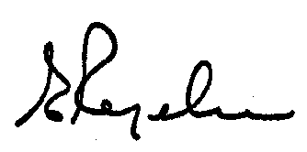
Canadians for a Nuclear Weapons Convention
Steering Committee:
Ernie Regehr, O.C. (Chair)
Jennifer Allen Simons, C.M.
Douglas Roche, O.C.
Adele Buckley
Bev Tollefson Delong
Cesar Jaramillo

cc: The Hon. Anita Anand, P.C., M.P., Minister of National Defence
The Hon. Pierre Poilievre, P.C., M.P., Leader of the Opposition
Jagmeet Singh, M.P., Leader of the New Democratic Party
Yves-François Blanchet, M.P., Leader of the Bloc Québécois
Elizabeth May, O.C., M.P., Leader of the Green Party of Canada
APPENDIX 8
Response from Minister Joly

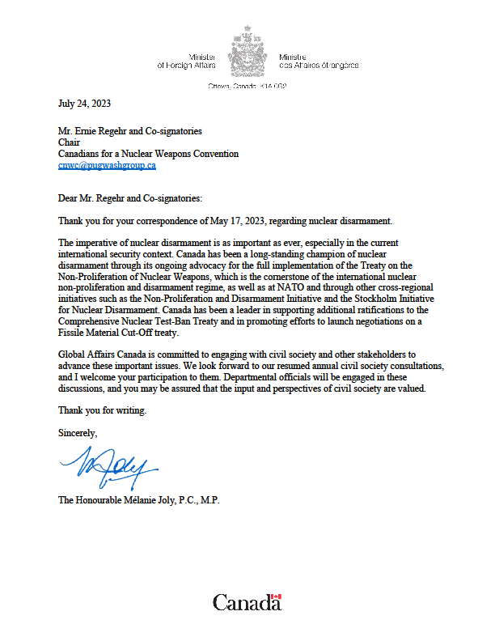
APPENDIX 9
Announcement of Paul Meyer as recipient of the 2022 CNWC Achievement Award

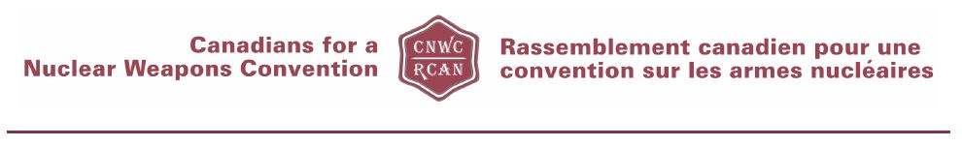
Media Release
Former Canadian Diplomat Paul Meyer
2022 CNWC Award Winner for
Nuclear Disarmament Leadership
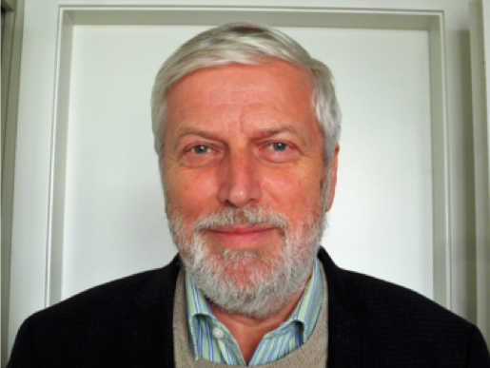

Paul Meyer, who, after a 35-year career with the Canadian Foreign Service, became a leading civil society advocate for nuclear disarmament, will receive the Canadians for a Nuclear Weapons Convention (CNWC) 2022 Distinguished Achievement Award.

Meyer has the rare achievement of being an experienced and successful career diplomat, including serving as Canadian Ambassador to the U.N. and the Conference on Disarmament in Geneva (2003-2007 and then a highly effective and respected civil society leader.

Meyer had diplomatic assignments in Oslo, Moscow, Brussels (NATO), Washington, and Tokyo as well as Geneva. Throughout his work, he sought to promote international security and conflict prevention by means of creative diplomacy. Currently, he is a Fellow in International Security and Adjunct Professor of International Studies at Simon Fraser University in Vancouver. He teaches a course on diplomacy at SFU’s School for International Studies. He is a past Chair of the Canadian Pugwash Group, a Senior Advisor with ICT4Peace, a founding Fellow of the Outer Space Institute and a member of the International Panel on Fissile Material. From 2011-2019, he was Senior Fellow at The Simons Foundation. Also, Meyer is engaged in research and writing on issues of Canadian diplomacy, nuclear non-proliferation and disarmament, outer space security and international cyber security.

CNWC is a civil society initiative sponsored by the Canadian Pugwash Group and endorsed by more than 1,000 recipients of the Order of Canada, who have called for Canada to work for comprehensive negotiations for the elimination of nuclear weapons. “We are proud to give this year’s Award to Paul Meyer because both the Government of Canada and civil society have benefitted from his lengthy diplomatic experience and detailed knowledge of multiple treaties and their operation,“ said Ernie Regehr, CNWC Chairman.

The Award will be presented Nov. 28 at a reception following Meyer’s lecture, "Nuclear Threats and Canada's Disarmament Diplomacy,” sponsored by CNWC and the Centre for International Policy Studies (CIPS) at the University of Ottawa, Room 4007, 120 University Private, Ottawa. The lecture, beginning at 4 pm, is open to the public.

Previous recipients of the CNWC Achievement Award are:
2011 Murray Thomson
2012 Bev Delong
2013 Fergus Watt
2014 Adele Buckley
2015 Paul Dewar
2016 Peggy Mason
2017 Metta Spencer
2018 Debbie Grisdale
2019 Dr. Mary-Wynne Ashford and Dr. Jonathan Down
2021 Dr. Jennifer Allen Simons
*************
Contact: Elaine Hynes CNWC
cnwc@pugwashgroup.ca
APPENDIX 10
Paul Meyer featured in a report by The Hill Times

Advocates want Canada to take up historic arms control leadership role in fight for nuclear disarmament

Canada's past work as a champion in the fight to ban landmines in the 1990s should guide Ottawa's approach to nuclear disarmament, say advocates.
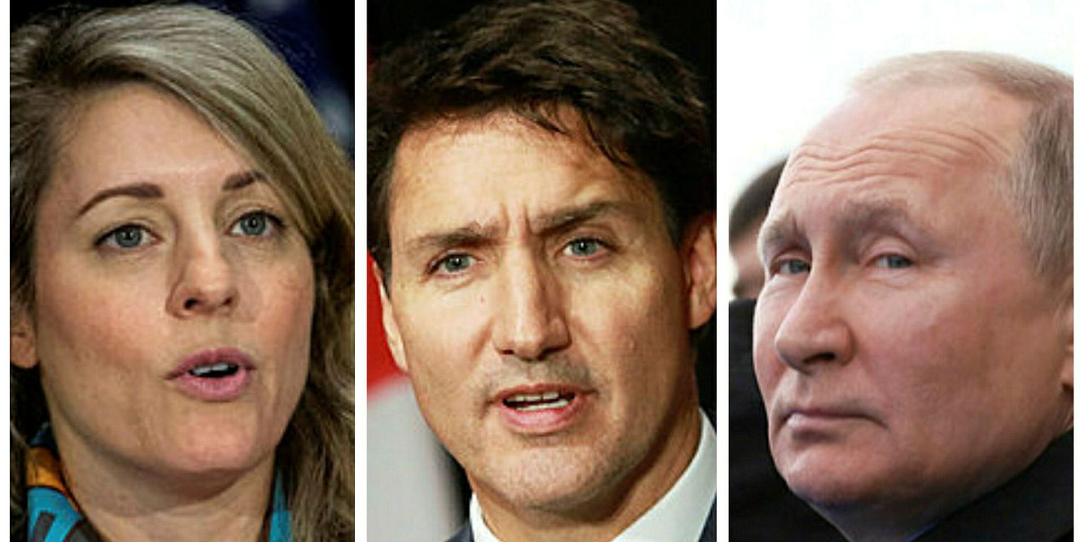
Russian President Vladimir Putin's, right, sabre rattling on nuclear threats has brought little focus on nuclear disarmament from Prime Minister Justin Trudeau and Foreign Affairs Minister Mélanie Joly, say experts. The Hill Times photographs by Andrew Meade and Sam Garcia and photograph courtesy of Wikimedia Commons

NEWS | BY NEIL MOSS | November 30, 2022
With threats of deploying nuclear weapons amid Russia’s invasion of Ukraine, disarmament advocates and experts are hoping that Canada uses the spotlight to return to its historic role as a champion of disarmament.
Bucking the request of some NDP and Green Party MPs and state parties, Canada chose not to attend the first meeting of the state parties of the Treaty on the Prohibition of Nuclear Weapons (TPNW) in June. Instead, the Canadian government has highlighted its commitment to the Treaty on the Non-Proliferation of Nuclear Weapons (NPT), which has been in force since 1970. Advocates argue both treaties are effective tools towards nuclear disarmament. While the NPT limits non-nuclear states, the TPNW strives to eliminate nuclear weapons altogether.
Ninety-one countries have signed the TPNW, but no NATO country is a member, nor is any nuclear weapon power.
Paul Meyer, former Canadian ambassador to the UN conference on disarmament, said he sees hope and pitfalls amid current geopolitical turmoil to advance the cause of nuclear disarmament.
“It’s good news and bad news. The bad news is that nuclear weapons are back in view and the good news is that nuclear weapons are back in view,” he said in a Nov. 28 interview in Ottawa.
He said nuclear weapon threats shook an assumption people around the globe held that the thousands of nuclear weapons that are stockpiled can be ignored.
“[It was] a rude awakening to be reminded as a result of [Russian] President [Vladimir] Putin’s nuclear sabre rattling that these nuclear weapons of mass destruction are very much still with this. That they can be used irresponsibly in issues of coercion and intimidation,” he said. “It’s not only a problem of whose hands they are in, but a problem inherent in the existence of weapons, the use of which would be devastation and also a gross violation of international humanitarian law.”
He said that the threats may galvanize attention towards nuclear disarmament.
Putin has said that nuclear weapons could be used in Ukraine if needed, but many experts have downplayed the real threat of the “nuclear taboo” being broken.
Meyer was in Ottawa to receive a distinguished achievement award from the Canadians for a Nuclear Weapons Convention.
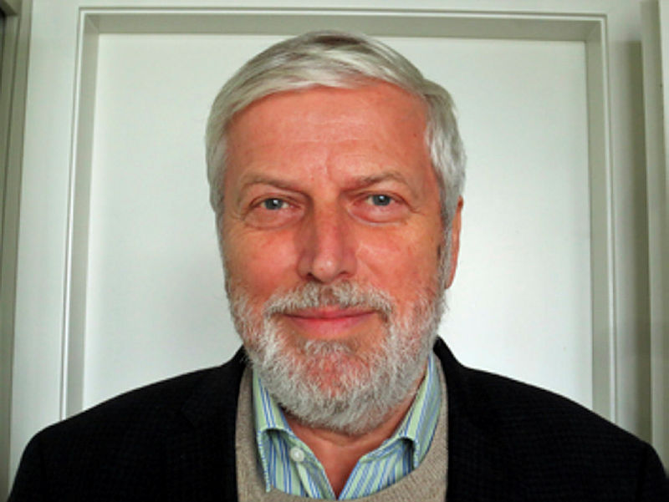
Former diplomat Paul Meyer says the spotlight on nuclear threats is ‘good and bad news’ for the fight for disarmament. Photograph courtesy of Paul Meyer
He said some diplomacy options have been reduced given the Russian invasion and the West’s international isolation of Moscow.
“You don’t make progress by just talking to your friends,” he said. “You have to be prepared to engage adversaries and we need to get back to that.”
When the Strategic Arms Limitation Talks treaties between the United States and the former Soviet Union were reached in the 1970s, Meyer said it wasn’t amid a “rosy” international security atmosphere.
While in Ottawa, Meyer held meetings with arms control and disarmament officials at Global Affairs.
The former diplomat said Canada’s NATO membership doesn’t preclude it from playing an active role on nuclear disarmament.
“You don’t give up your sovereignty when you become a NATO member,” he said.
“The current NATO nuclear policy is just that—a policy. [It] can be changed. It’s not a legal requirement for membership,” he said. “I do hope that Canada will be a voice of moderation.”
He noted the work that Canada has done historically on disarmament, including as part of the Ottawa Treaty to ban the use of landmines in the 1990s, which was advanced by then-foreign affairs minister Lloyd Axworthy.
“We weren’t just sitting back waiting for others to do the right thing that we were championing,” Meyer said, remarking that Canada should be an observer at the next meeting of the state parties to the TPNW.
Concerns over North Korea’s ballistic missile program and its nuclear weaponry threat has also pushed calls for nuclear disarmament.
The Canadian government’s recently released Indo-Pacific strategy supports South Korea’s goal to achieve a “denuclearized, peaceful, and prosperous Korean Peninsula.”
Royal Military College and Queen’s University professor Jane Boulden, an expert on the United Nations and nuclear disarmament, said Canada has stuck to the NATO line of the TPNW.
“I think we are a distance [away] from where we used to be in the international community in terms of our role and status on arms control issues. We’re not as much as an active participant or a leader as we used to be,” she said.
Boulden said Canada used to be able to find areas as a non-nuclear power to move the arms control debate along, noting Ottawa’s work on verification and compliance.
“We’re mirroring the NATO line and not necessarily doing a whole lot else. We could, but we’re not,” she said.
She said one aspect of that positioning is that it looks like nuclear deterrence is working.
“Russia has been very clear in not wanting to engage the prospect of [nuclear] escalation and the same thing in reverse,” she said.
The Canadian government has responded to Russia’s invasion of Ukraine with a number of levers, including arms support for Kyiv and economic sanctions on Moscow, but has been seemingly muted in addressing nuclear disarmament during the situation.
Green Party MP Elizabeth May (Saanich-Gulf Islands, B.C.) said in the House of Commons on Oct. 31 that it was a “profound disappointment” that Canada didn’t send a delegation to the first meeting of state parties of the TPNW.
“We must do more to end the threat of nuclear war. As we look at Canada’s role as a member of NATO and what is happening right now with Vladimir Putin mentioning specifically the potential threat of using nuclear weapons, that must be denounced so strongly at all times,” she said.
May cited the role Canada had performed when campaigning for the Ottawa Treaty on landmines.
“Had we pursued aggressively the work we should do as a non-nuclear state without being so subservient to our nuclear state neighbour, as we did in the Ottawa Treaty to ban landmines, we could perhaps have kept the world much safer from Vladimir Putin,” she remarked.
Liberal MP Robert Oliphant (Don Valley West, Ont.), parliamentary to the foreign affairs minister, responded that Canada has a “clear policy” of disarmament and non-proliferation.
“The NPT, a treaty with near-universal adherence, is at the root of Canada’s nuclear policy. It is also unquestionably the cornerstone of the international nuclear non-proliferation and disarmament regime,” he said.
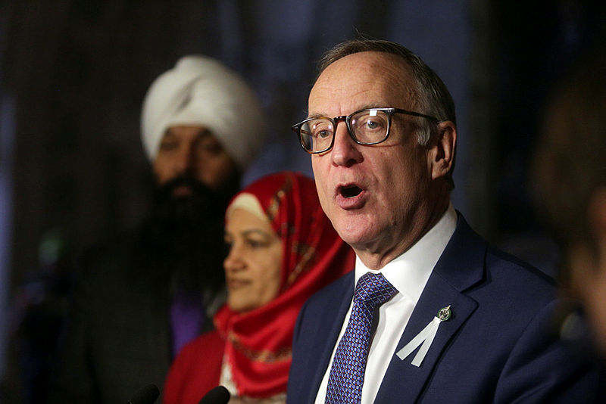
Liberal MP Robert Oliphant says nuclear deterrence is the current reality of the world. The Hill Times photograph by Andrew Meade
He remarked that “several” of the TPNW’s commitments are “incompatible” with Canada’s NATO obligations.
Oliphant also noted that nuclear deterrence is “currently a reality.”
Canadian Global Affairs Institute fellow Julie Clark, who studies nuclear disarmament, said Canada should return to its historic position of not being afraid to speak out unilaterally in support of arms control and nuclear disarmament.
“Canada has often been able to balance our responsibilities and commitments to the belief that we can contribute to a better world in some way,” she said. “What’s happening right now, is there seems to be more a desire to follow and stay within the stated messaging from our allies, from NATO. There is a lack of independent boldness that Canada has [shown] on the world stage previously.”
“We are taking a more subdued approach at this moment,” Clark said.
She said it is essential for Parliament to hold a debate on the future of nuclear weapon prohibition.
“The House of Commons needs to have a conversation about this,” she told The Hill Times. “The fact that two parties really want to engage in a conversation on this, and the Conservatives, they want a say in this as well because they have a different position than either side. … So they all need to have a conversation.”
That parliamentary debate should include a discussion on Canada’s humanitarian and NATO commitments, which Clark said will require “boldness and bravery.”
That debate would allow Canada to define its position and explain why it is positioning itself in such a way, she said.
nmoss@hilltimes.com
The Hill Times
APPENDIX 11
CNWC Steering Committee Announcement

