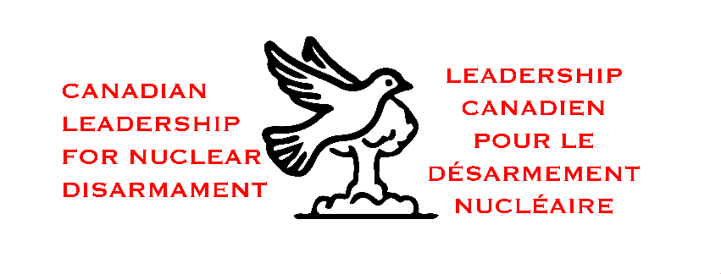
“Canadians for a Nuclear Weapons Convention” Announces Name Change to “Canadian Leadership for Nuclear Disarmament”
May 8, 2025 – Canadians for a Nuclear Weapons Convention (CNWC) is pleased to announce its new name: Canadian Leadership for Nuclear Disarmament (CLND). This change is to enable the organization’s name to better describe the breadth of the work we have done and will continue to do.
As a project of the Canadian Pugwash Group, the organization continues to unite over 1,000 recipients of the Order of Canada in advocating for global nuclear disarmament. CLND remains dedicated to its core objective:
“To call on all member states of the United Nations – including Canada – to endorse, and begin negotiations for, a Nuclear Weapons Convention.”
CLND recognizes that the pursuit of a comprehensive convention requires attention to the full spectrum of nuclear disarmament issues.
The name change explicitly acknowledges the endorsement of nuclear disarmament by a large group of leading Canadians who are recipients of the Order of Canada, and also that CLND urges Canada to take on a genuine leadership role in nuclear disarmament diplomacy broadly and in preparatory work towards a nuclear weapons convention.
“This updated name better represents our ongoing commitment to addressing the full spectrum of nuclear disarmament issues and conveys what we expect from our government in rising to that urgent global challenge,” said Alex Neve, the Chair of the Steering Committee of CLND. “While our mission remains the same, our renewed identity reflects the leadership that is needed, from government and from civil society, in pushing for concrete action.”
CLND aims to strengthen Canada’s role in fostering a world free of nuclear weapons through advocacy, policy recommendations, and public engagement. The organization will continue to work closely with policymakers, civil society, and international partners to advance diplomatic solutions and promote Canada’s active participation in nuclear disarmament negotiations.
For more information, please contact:
Alex Neve, Steering Committee Chair
Canadian Leadership for Nuclear Disarmament
Email: CLND@pugwashgroup.ca
Website: https://pugwashgroup.ca/clnd/

