UN Secretary-General Ban Ki-Moon’s five point proposal, point 1, says:
I urge all NPT [Treaty on the Non-Proliferation of Nuclear Weapons] parties, in particular the nuclear-weapon States, to fulfil their obligation under the Treaty to undertake negotiations on effective measures leading to nuclear disarmament. They could pursue this goal by agreement on a framework of separate, mutually reinforcing instruments. Or they could consider negotiating a nuclear-weapons convention, backed by a strong system of verification.

This statement recognizes that the arms control and disarmament community will work toward the goal of comprehensive and complete nuclear disarmament through negotiations. Recently a peace movement colleague spoke about the necessity of pursuing negotiations “in parallel”, rather than “in series”; the main rationale was that the various negotiations that enable nuclear disarmament must be handled in a timely manner. The parallel vs. series idea is worth expanding, by reference to standard electrical circuitry. Although, for this analogy, one considers the concept of resistance; no prior electrical knowledge is required.
In this context, resistance may be viewed as obstacle(s) that must be cleared before negotiation is completed. In the case of nuclear disarmament negotiations, obstacles could be, for example – technical, procedural, financial and/or inadequate political will. Some typical nuclear negotiations areas would be:
- Fissile Material Cut-off
- Strategic and Tactical Nuclear Weapons Reduction
- Credible Verification Methodology
- …and several others
Each negotiating item above would conclude when the particular obstacles associated with it had been overcome. Therefore rating of the difficulty of overcoming the obstacles associated with each item would be labelled the Resistance, and for the list above, we have Resistance 1 (R1), Resistance 2 (R2), Resistance 3 (R3), up to Resistance n (R_{N}) where “n” is the number of negotiations to be undertaken to yield mutually reinforcing instruments. Therefore, if each new negotiation is started when the previous one is completed, the sequence can be depicted as in Figure 1.
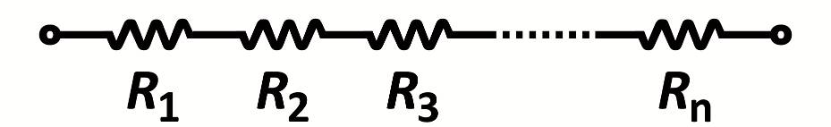
Figure 1 - Negotiations, in series
 | The total resistance is | 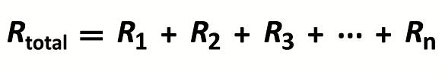
In addition, for parallel negotiations, Figure 2, the time lapsed would be that of the longest negotiation; for serial negotiations one must add time taken for every individual negotiation.
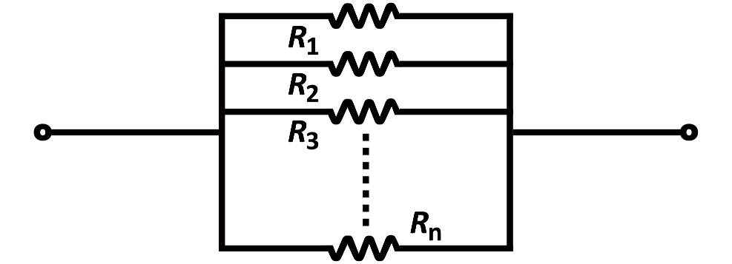
Figure 2 – Negotiations, in parallel
 | The total parallel resistance is given by | 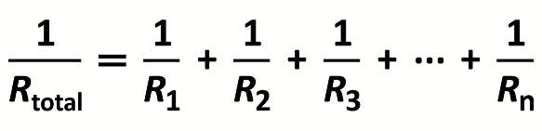
Then, it is seen that for the series case, the total Resistance is larger than the largest single resistance; for the parallel case, the total resistance is smaller than the smallest single resistance. In other words, the resistance (obstacles to be overcome in negotiating) is much less in the parallel case than in the serial case. This will be more readily seen by taking a simple example, just three negotiations, R1, R2, and R3, and assigning each a numerical value, where the higher the number is, the greater is the obstacle course to overcome. Say that R1=100; R2=400; R3=200
Then, for the Series Negotiations, R_{total} = 100 + 400 + 200 = 700
For the Parallel Negotiations, 1/ R_{total} = 1/100 + 1/400 + 1/200 and R_{total} = 57
In this example, the parallel negotiation has a resistance to obstacles that is only 8% of the resistance of the series negotiation. Not only that, but if a segment of a series negotiation breaks down, then the entire work comes to a halt; whereas in a parallel negotiation, the work can continue via another path. In the real world, both series and parallel negotiations are occurring; parallel should be strongly favoured.
Human behaviour has been observed before to be analogous to the behaviour of nature (in this case, it is the proven laws of electricity). It is important to consider this analogy now, as we are experiencing a rising pressure to start negotiations toward a nuclear weapons convention (NWC). In fact, direct negotiation for a NWC can be added to the list above, and be carried out in parallel to other activities in arms control and disarmament. The insight to be gained from this electrical analogy is simply that there is a very strong case to be made for parallel negotiations on all segments of the nuclear disarmament issues, because there is a built-in advantage. Reaching the goal will be easier; one might guess that this arises from known inter-connectedness of problems.

http://www.un.org/News/Press/docs/2008/sgsm11881.doc.htm
Robin Collins, United Nations Association (Canada) at CNANW annual meeting, Ottawa, April, 2011
Resistance, as a physical circuit element, determines the electrical current that will be carried when a voltage is applied.

